Chapter 3, Solution 57

In the circuit in Fig. 3.102, find the values of R, V₁, and V₂ given that i_{o} = 15 mA.

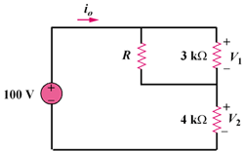

90 V

Figure 3.102
For Prob. 3.57.

Solution
Assume R is in kilo-ohms.
= 30 V
Current through R is
This leads to R = 90/15 = 6 kΩ.

